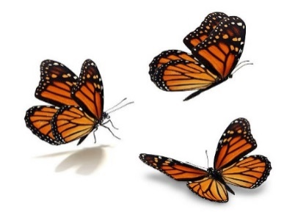
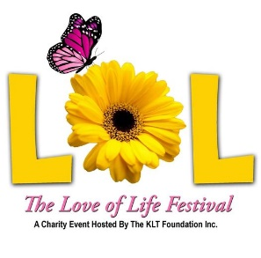

Love of Life Festival


Saturday, March 7, 2026

12 pm – 8 pm

At the beautiful Grand Oaks Resort

3000 Marion County Rd, Weirsdale, FL 32195

Art * Food * Raffles * Live Music * and Much More!

The Kathryn Leigh Thurgaland Foundation invites you to join us in celebrating life through music and art at the 5th annual Love of Life Festival at the beautiful Grand Oaks Resort located in Weirsdale Florida! This outdoor music and arts festival brings together an exciting mix of local artists and musical acts, creating a vibrant atmosphere for all ages. Guests can indulge in delicious food truck fare, sip refreshing drinks from the bar tent, explore unique artwork, and soak in the sounds of live performances. Bring your own seating and get ready to groove the day away at this exciting event!

​The KLT Foundation, founded by Kathryn’s immediate family, is dedicated to honoring her love of life through programs that support grieving families, celebrate human expression with the Love of Life Festival, and provide memorial scholarships to students who embody her passion for the arts. One of our cornerstone programs, the Love of Life Festival, is a music and arts festival that serves as a platform for artists and musicians to showcase their talents while offering a space to honor a loved one's legacy by celebrating their life, cherishing their memories, and keeping their spirit alive.

​Over the past four years, the Love of Life Festival has grown from a small grassroots gathering into a vibrant community celebration. Each year, hundreds of attendees from Central Florida and beyond gather to discover new talent, meet brilliant artists, and share experiences that range from live music and visual art to raffles, a silent auction, outdoor games, bounce houses, and face painting for the kids.

More than a festival, the Love of Life Festival is a day of joy, remembrance, and connection. It is a sacred moment for families and friends to come together — not only to celebrate art and community, but also to honor the lives of those who have passed. In the laughter, the music, and the shared stories, we find comfort, healing, and inspiration. This unique blend of celebration and remembrance is what makes the Love of Life Festival so special. It’s where life is cherished, love is remembered, and community shines the brightest.

We invite you to help us continue this mission by becoming a sponsor. Sponsorship opportunities offer unique promotional benefits for your company, while also giving your friends, family, and employees the chance to be part of the joy and healing that the Love of Life Festival brings. When your organization sponsors the Love of Life Festival, you’re not just supporting an event — you’re joining a movement that celebrates life, uplifts the arts, and strengthens our community. Please join us. Together, we can keep love and life alive.
Perks  - Banner displayed at key areas *  - Mentioned during announcements *  - Logo placement on stage *  - Booth space for marketing  - Logo & Link on marketing material  - Festival T-Shirts *  - Tickets to Festival * | Sponsorship Levels  - Diamond $10,000  - Platinum $7,500  - Gold $5,000  - Silver $2,500  - Bronze $1,000  - Friends $500

*Some benefits are exclusive to their respective sponsorship level

 | 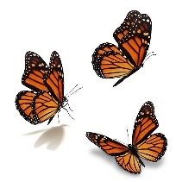 | 

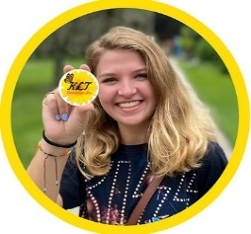
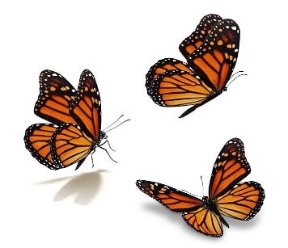
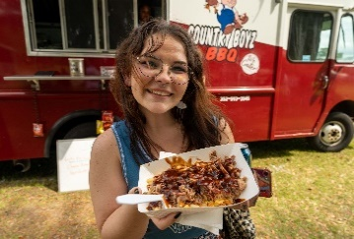
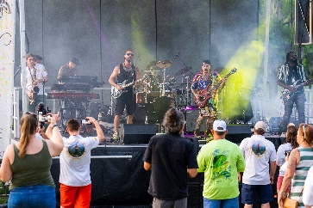
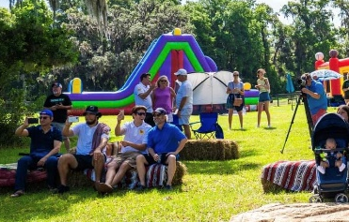
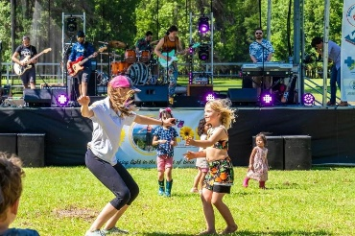

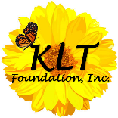
FOR MORE INFORMATION VISITS www.kltfoundation.com/lolfestival
OR CONTACT JODELL THURGALAND AT CONTACT@KLTFOUNDATION.COM

Love of Life Festival

Saturday, March 7, 2026 | 12 pm – 8 pm |Grand Oaks Resort

Sponsorship Agreement

SPONSOR INFORMATION

Company Name:

Contact Name:

Address:
Email: |  | Phone:

Day-of Contact:
Email: |  | Phone:

SPONSORSHIP LEVEL (See detailed benefits on page 4)
• Diamond $10,000 |  | • Silver $2,500
• Platinum $7,500 |  | • Bronze $1,000
• Gold $5,000 |  | • Friends $500

BOOTH INFORMATION

Please indicate if you intend to use your own tent or if you wish to have on provided (tents limited to 10’ x 10’). Tables, chairs, and lights not provided.

Using own branded tent Request tent be provided

Please describe the services and productions you intend to provided at the event:

Sponsorship agreement, company logo (please email), and payment can be returned to:

Kathryn Leigh Thurgaland Foundation

Love of Life Festival

P.O. Box 1188, Ocklawaha, FL 32179

contact@kltfoundation.com | 352-804-4960

EVENT TERMS & GUIDELINES

Exhibit Space

• Exhibits must be open and staffed for the entire duration of the event.

• The entire booth (including tent, tables, displays, etc.) must fit into your approved booth space

• Identification signs must be presented at the front of the tent and shall be not be longer than the width of the tent (10’).

• Tents must be no larger than 10 x 10 and anchored securely. Spring time is Florida is breezy, so plan on extra weights to secure your tent.

• All sponsors are responsible for providing their own supplies including, but not limited to, fire extinguishers, trash

cans, trash bags, lights, extension cords, cord covers, etc.

• Sponsors are responsible for maintaining their booth and surrounding areas during and after the event.

• Sponsors must dispose of all trash (cardboard boxes must be broken down) in event dumpsters not in

trashcans provided for public use. Booth space should be left clean after tear-down; no trash, trash bags, empty

boxes, etc.

• Amplification/music of any kind at your booth is prohibited.

Power is not provided at this venue

• All generators must be grounded.
- If larger than 5KW (5000 Watts) an additional permit is required through the Sumter County Building Dept.
- Generators must be 10ft away from any structure, completely surrounded by a barrier and placed on a firm, flat, level surface outdoors.
- Must be fully fueled prior to use. Refueling may be conducted only when generator has been turned off and is cool to touch. All fuel being used in the generator must be stored in the proper fuel containers and properly sealed with appropriate spout covers, caps, etc.
- A proper certified fire extinguisher (minimum 2A:10BC) must be present and properly tagged.

Additional Guidelines

• Exhibitors are PROHIBITED FROM SMOKING WITHIN THE EVENT SITE.

• “Pushing” sales to passing customers is prohibited.

• Sponsors are responsible for collecting and reporting sales tax on all sales.

Check-in, Set-up, and Breakdown

• All sponsors must check in with their designated event coordinator, who will be present to meet them at

the check-in area. Maps will be provided to all vendors with check-in information prior to the event.

• Setup will take place between 8 a.m. and 11:30 a.m. You must check-in NO LATER THAN 10:30 a.m. to setup your booth space. All vehicles must be out of the event zone by 11:30 a.m.

• Exhibits must be open and staffed for the entire duration of the event.

• Sponsors can begin breakdown early, but no vehicles will be allowed into the event area until cleared by the

appropriate event personnel.

Marketing

• The Kathryn Leigh Thurgaland Foundation will create flyers/posters and videos for event. Digital versions of these materials will be made available to you for social media distribution. You may contact various businesses and ask if they will post the information within their business.

• We encourage our sponsors to promote their participation with the event. However, the following cannot be

done by any vendor or sponsor:

o Create/sell items bearing the event name or likeness or event logo

o Use copywritten photos/materials as your own

o Create events on Facebook (or any other social media/website) using official event name or logo.

However, links to the Love of Life Festival Facebook page/event page and website are permitted

and will be provided upon request.

• Please contact the Kathryn Leigh Thurgaland for questions regarding digital or print marketing and to obtain approved promotional materials at contact@kltfoundation.com.

SPONSOR AGREEMENT

The sponsor certifies that the information on the sponsorship agreement is a correct depiction of the services and

products to be provided by the sponsor at the event. The sponsor understands that failure to follow

application/sponsor permit terms as described and stipulated herein may result in ineligibility for this and future events. The sponsor further agrees to abide by all terms of the sponsor permit for this event and to hold harmless and indemnify the Kathryn Leigh Thurgaland Foundation, and The Grand Oaks Resort, against any claims arising by virtue of their occupancy of exhibitor space and participation in this event.

GENERAL RELEASE

I am entering into a contract to participate in the Love of Life Festival on Saturday, March 7, 2026. I agree to abide by all management's rules and regulations. I understand this contract will be legally binding between two parties once the application has been accepted. Sponsors should insure their own exhibit and display materials. The Kathryn Leigh Thurgaland Foundation does not and will not assume liability for theft, injury, or any other accident that may occur during the event to visitors or vendors.

I understand that, if accepted into the event, my Sponsor fee shall not be refunded if all or part of the event is cancelled, including but not limited to inclement weather or acts of nature.

I HAVE READ ALL THE RULES PERTAINING TO THIS APPLICATION/CONTRACT AND AGREE TO ABIDE BY THEM.

Sponsor name (please print): ____________________________________________________________

Signature: ______________________________________________________ Date: ________________

Benefits & Media Recognition

Diamond Sponsor - $10,000

• Limited to one cash sponsor

• Banner over Monarch stage

• Opportunity of address attendees from stage

• 12 tickets to the event

• 2 Festival t-shirts

• Reserved 10’ x 10’ booth space and tent (if requested) in prime location

• Logo placement on stage

• 8 x 4 banner with logo displayed

• On-stage verbal recognition

• Company name and/or logo recognition on stage signage, Media release, Event webpage, social media, Event Signage, Digital & print marketing materials

Platinum Sponsor - $7,500

• Limited to one cash sponsor

• Opportunity of address attendees from stage

• 10 tickets to the event

• 2 Festival t-shirts

• Reserved 10’ x 10’ booth space and tent (if requested) in prime location

• Logo placement on stage

• 8 x 4 banner with logo displayed

• On-stage verbal recognition

• Company name and/or logo recognition on stage signage, Media release, Event webpage, social media, Event Signage, Digital & print marketing materials

Gold Sponsor - $5,000

• Limited to two cash sponsor

• Banner at bar

• 8 tickets to the event

• 2 Festival t-shirts

• Reserved 10’ x 10’ booth space and tent (if requested) in prime location

• Logo placement on stage

• 8 x 4 banner with logo displayed

• On-stage verbal recognition

• Company name and/or logo recognition on stage signage, Media release, Event webpage, social media, Event Signage, Digital & print marketing materials

Silver Sponsor - $2,500

• Limited to 10 cash sponsor

• Signage in key areas

• 6 tickets to the event

• 2 Festival t-shirts

• Reserved 10’ x 10’ booth space and tent (if requested) in prime location

• Logo placement on stage

• 8 x 4 banner with logo displayed

• On-stage verbal recognition

• Company name and/or logo recognition on stage signage, Media release, Event webpage, social media, Event Signage, Digital & print marketing materials

Bronze Sponsor - $1,000

• 4 tickets to the event

• 2 Festival t-shirts

• Reserved 10’ x 10’ booth space

• Logo placement on stage

• 8 x 4 banner with logo displayed

• Company name and/or logo recognition on: Event webpage, social media, and emails

Friends Sponsor - $500

• 2 tickets to the event

• Reserved 10’ x 10’ booth space

• Company name and/or logo recognition on: Event webpage, social media, and emails

